**Hess Opportunty Management System Architecture**

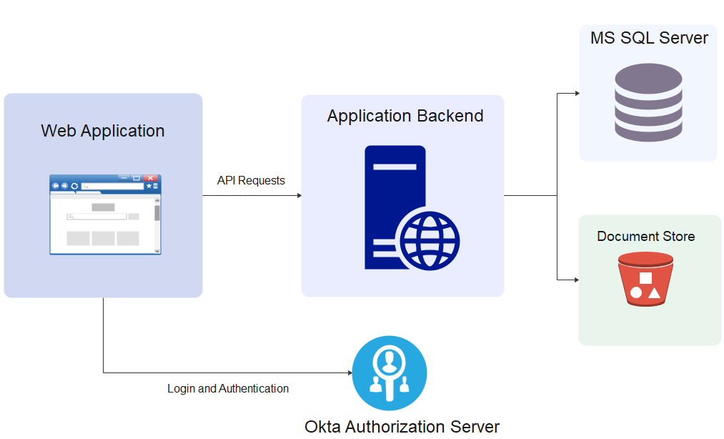

Hess Opportunity Management is a web application that allows the users to enter, track, rank, and select new technology opportunities received from partners in the Energy sector. Opportunities tracked in the system will be evaluated, ranked, and selected for testing and development and then moved on to implementation.

The application will be implemented as a Single Page Application. Authentication will be achieved using Okta SSO and the backend will be implemented in Express NodeJS. The application will also use MS SQL Server as the underlying RDBMS for the system.

**Authentication and Authorization:**

Authentication will be done using Okta Authorization Code Flow with PKCE. The application will use Okta-provided SDKs for both frontend and backend in order to add authentication functionality to the application. The frontend will be responsible for redirecting the user to the correct login page and storing the access token. When making requests to the backend, the token will be provided in the Authorization Header.

The backend will validate the access token; Claims present in the token are used to identify the user and determine whether a user access to view or edit an opportunity.

**Scheduled Tasks:**

The application is also responsible for notifying the relevant users whenever an Opportunity has encountered a possible bottleneck. This will be implemented as a regularly scheduled task that will check for bottlenecks and create notifications as needed.

**Technology Stack:**

* Express NodeJS
* MS SQL Server
* Okta